Name: Mukesh Prajapati
Date: FEB/15/2018, Created
Brief: GIT version control system documentation

Introduction

An indispensable tool in modern software development is some kind of version control system. Version control systems allow you to keep track of your software at the source level. You can track changes, revert to previous stages, and branch to create alternate versions of files and directories.

One of the most popular version control systems is git, a distributed version control system. Many projects maintain their files in a git repository, and sites like GitHub and Bitbucket have made sharing and contributing to code simple and valuable.

1. How to install git?

Open terminal and run the following commands,

$ sudo apt-get update
$ sudo apt-get install git

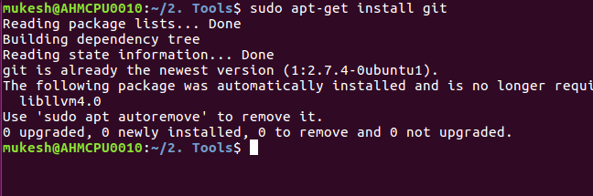
If the git is already installed then as shown in above image the output will be displayed.

2. Configuring GitHub

Pre-condition: For configuring GitHub you should be GitHub user.
Then follow the commands,

$ git config --global user.name "your git username"
$ git config --global user.email "your email id"

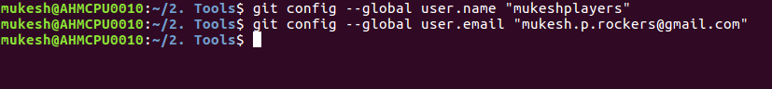

3. Creating a local repository

Intialize a local repository in your system by following command,

$ git init

Example:
mukesh@AHMCPU0010:~/Training $ git init
Initialized empty Git repository in /home/mukesh/Training/.git/

4. Creating a README file to describe the repository

Now create a README file and enter some text like "this is a git setup on linux". The README file is generally used to describe what the repository contains or what the project is all about. Example:

$ gedit Readme

You can use any other text editors. I use gedit. The content of the README file will be:

This is a git repo

5. Adding repository files to an index

To add any file or folder into repository follow the command,

$ git add MyFolder

6. Commit

Commit is used to save the data. -m is used for providing comment or message. Follow the command,

$ git commit -m "some_message"

7. Create repository on GitHub

Go to your github page, Click on NEW.

Create a new repository page will be opened.

Add “Repository name” and “Description” as show in below image.

Click on “Create Repository”.
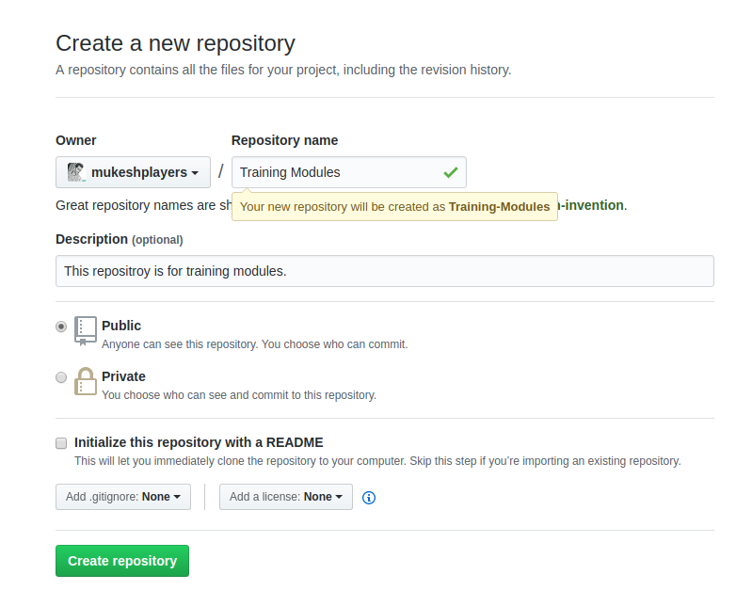
Then follow the command,

$ git remote add origin https://github.com/user_name/yourRepositoryName.git

It will ask for username and password of your GitHub account.

8. Push files into GitHub repository

$ git push origin master
